**STEP 1**

Remove the backing paper 100mm at a time. Align the top of the adhesive strip with the top edge of the shower tray or bath and firm press on by hand.

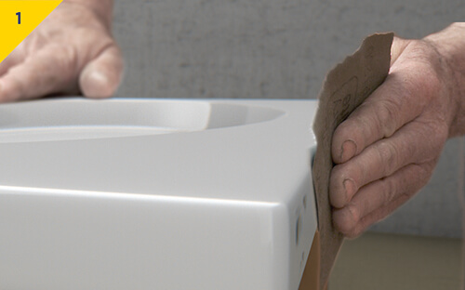

**STEP 2**

Thoroughly rough and clean the sides of the tray or bath that the Classi Seal is to be attached.

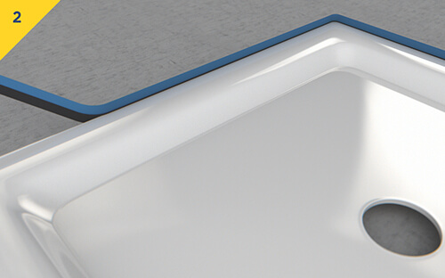

**STEP 3**

Manipulate and widen the upstand at corners. Upstand is easy to manipulate by hand to fit into irregular internal corners which are not square, so as not to interfere with the tiling.

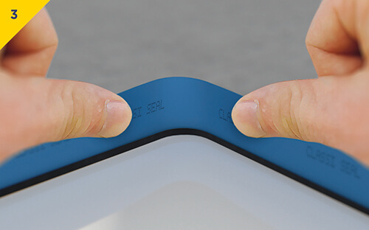

**STEP 4**

**Tiling can begin immediately.**

Following tiling or wall panelling, finish with a Neutral Cure Sanitary Grade 100% Silicone. Classi Seal prevents leakage from around shower trays and baths caused by the inevitable shrinkage and movement within buildings.

